Whats is Regression?  
Ans.In statistical modeling, regression analysis is a statistical process for estimating the relationships among variables. It includes many techniques for modeling and analyzing several variables, when the focus is on the relationship between a dependent variable and one or more independent variables (or 'predictors').  
Regression is nothing but the Prediction.  
**For Applying SLR,**

* Data Type must be ***Numeric*** or ***Continuous***.
* There should be ***One dependent variable and One independent variable***

The Linear relation between two variables which is a relation between dependent and independent variable.

***Note: In SLR the model can have only one dependent variable and one independent variable.***

**SLR can be defined as,**

**Y = α + β(x)+ Error**

Where, Y -> Dependent Variable  
α -> Constant  
β -> Coefficient  
x -> Independent Variable

Y = 123 +2.5 *15000+1…2.

=

So here,

* The variable Y is dependent on independent variable x.
* Both variable must be Numeric & Continuous

**SLR using R,**

We create a relationship model using the lm() functions in R,

**fit <- lm(formula=speed~dist,data=cars)**

* Basically, we are looking for R-squared measure just to see how close the data are to the fitted regression line. It is also known as the **coefficient of determination**.

It is defined as, R-squared = Explained variation / Total variation

Total variation = Explained variation + Unexplained variation

[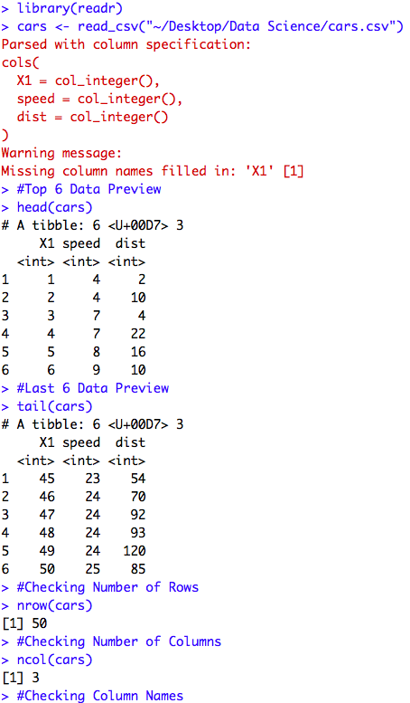](https://github.com/soumyasethy/Linear-Regression/blob/Implementation-Screenshots/preview1.png)  
[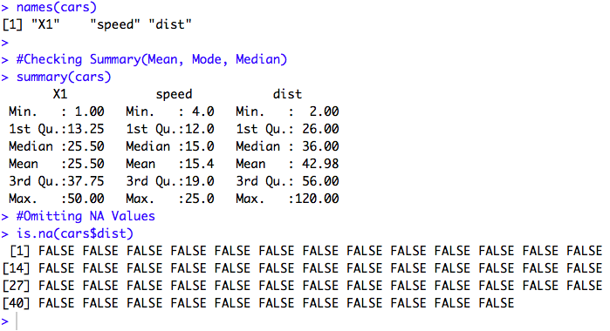](https://github.com/soumyasethy/Linear-Regression/blob/Implementation-Screenshots/preview2.png) [imple Linear Regression preview3](https://github.com/soumyasethy/Linear-Regression/blob/Implementation-Screenshots/preview3.png)  
[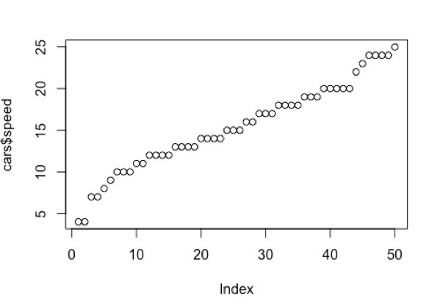](https://github.com/soumyasethy/Linear-Regression/blob/Implementation-Screenshots/preview4.png)  
[imple Linear Regression preview5](https://github.com/soumyasethy/Linear-Regression/blob/Implementation-Screenshots/preview5.png)  
[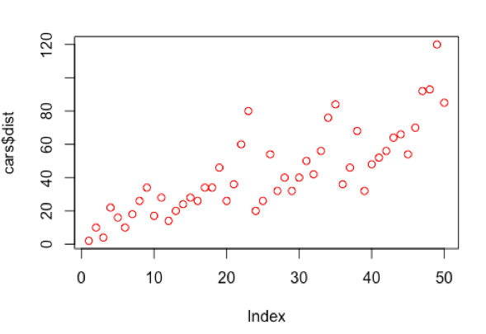](https://github.com/soumyasethy/Linear-Regression/blob/Implementation-Screenshots/preview6.png)  
[imple Linear Regression preview7](https://github.com/soumyasethy/Linear-Regression/blob/Implementation-Screenshots/preview7.png)  
[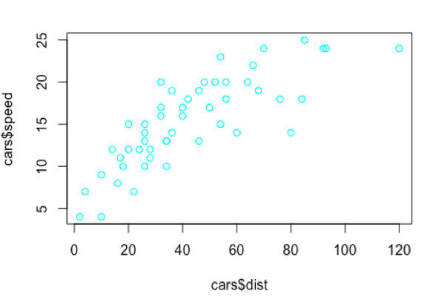](https://github.com/soumyasethy/Linear-Regression/blob/Implementation-Screenshots/preview8.png)  
[imple Linear Regression preview9](https://github.com/soumyasethy/Linear-Regression/blob/Implementation-Screenshots/preview9.png)  
[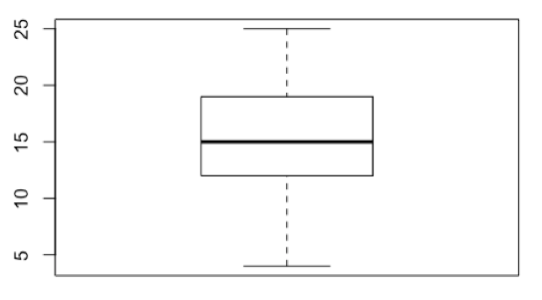](https://github.com/soumyasethy/Linear-Regression/blob/Implementation-Screenshots/preview10.png)  
[imple Linear Regression preview11](https://github.com/soumyasethy/Linear-Regression/blob/Implementation-Screenshots/preview11.png)  
[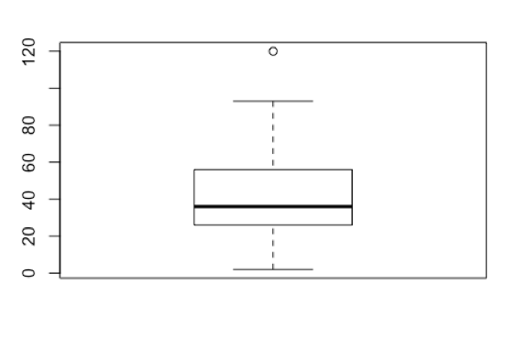](https://github.com/soumyasethy/Linear-Regression/blob/Implementation-Screenshots/preview12.png)  
[imple Linear Regression preview13](https://github.com/soumyasethy/Linear-Regression/blob/Implementation-Screenshots/preview13.png)  
[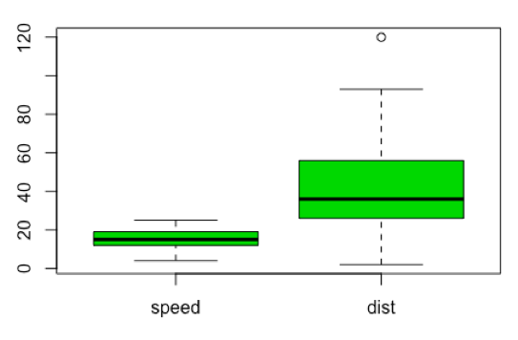](https://github.com/soumyasethy/Linear-Regression/blob/Implementation-Screenshots/preview14.png)  
[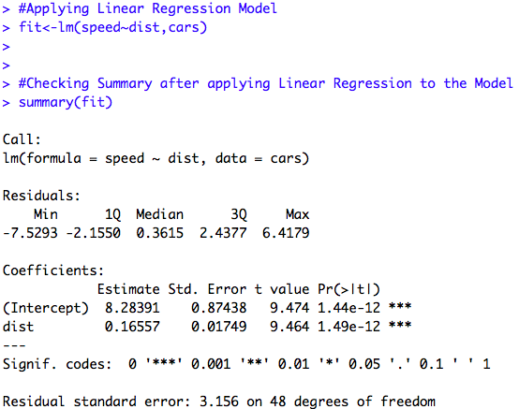](https://github.com/soumyasethy/Linear-Regression/blob/Implementation-Screenshots/preview15.png)

[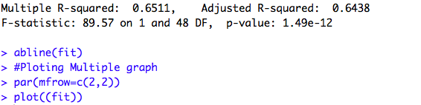](https://github.com/soumyasethy/Linear-Regression/blob/Implementation-Screenshots/preview17.png)

[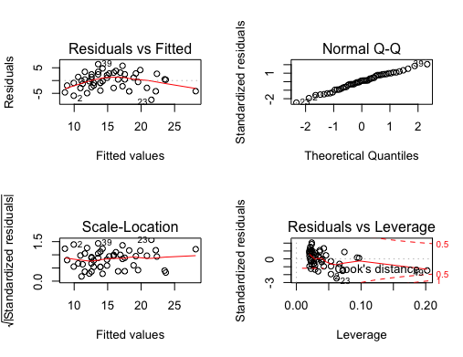](https://github.com/soumyasethy/Linear-Regression/blob/master/Rplot.png)

x